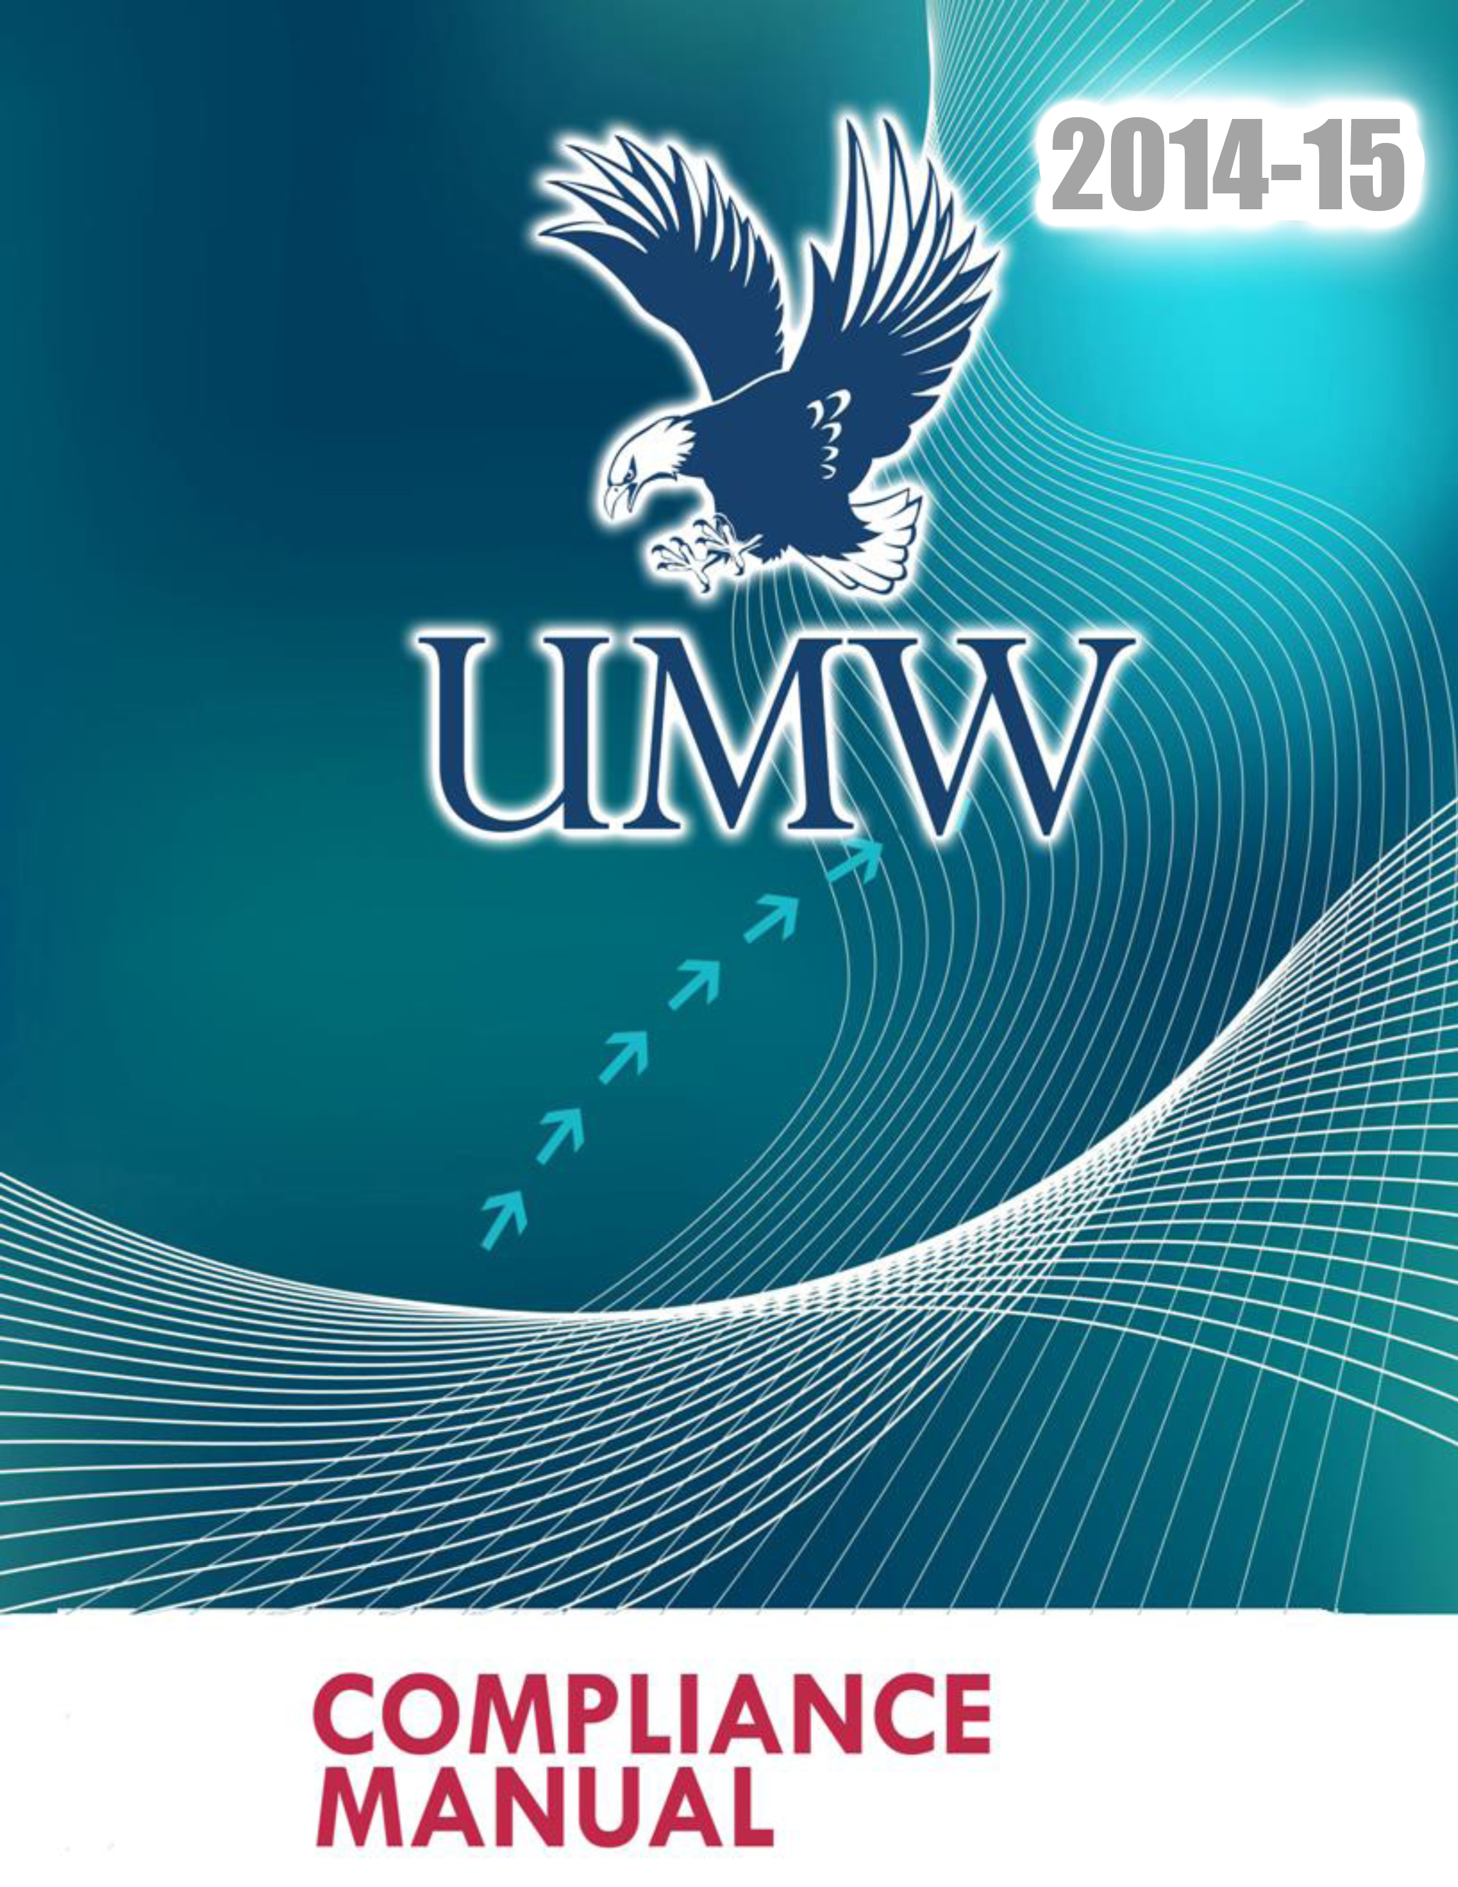

Table of Contents

INTRODUCTION 1
STAFF DIRECTORY FOR COMPLIANCE RELATED INFORMATION 2
ELIGIBILITY 2
REQUIREMENT FOR PRACTICE 4
REQUIREMENT FOR COMPETITION 5
TRANSFER REGULATIONS 7
TRANSFER EXCEPTIONS 8
RECRUITING 10
SOCIAL MEDIA 15
SPORTS CAMPS AND CLINICS 18
2013-14 DIVISION III COMPLIANCE FORMS 22
RELEVANT TOPICS AND OTHER NCAA RESOURCES 22

INTRODUCTION

Welcome to the University of Mary Washington Athletics Compliance home page! The goal of this site is to provide our alumni, fans, coaches, prospects and student-athletes information regarding the rules and regulations of the NCAA and the University of Mary Washington. While not all inclusive, it is meant to provide guidance in many of the situations you may encounter and should help you avoid inadvertently violating NCAA policies. Compliance with the rules and regulations is essential to creating a winning environment for all UMW athletic teams. In addition to being online, a hard copy of this manual is also available in the main athletics office.

University of Mary Washington Athletics Compliance Mission Statement
To ensure that the University of Mary Washington Athletic program operates in accordance with the rules and regulations set forth by the NCAA, the Capital Athletic Conference and the University of Mary Washington. The compliance office is committed to educating every member within UMW Athletics of the rules and regulations provided by the NCAA in an effort to prevent even minor infractions. In the case of a by-law violation, the compliance office will aim to identify, evaluate, and report the violation to the Capital Athletic Conference and NCAA.

NCAA Principles Rules of Compliance
Per the NCAA Constitution, a member institution will comply with all applicable NCAA rules and regulations. An institution is also responsible for monitoring its athletics program to assure compliance for identifying and reporting all instances in which compliance has not been achieved.

STAFF DIRECTORY FOR COMPLIANCE RELATED INFORMATION

First Name | Last Name | Title | Phone(540) | Email
Ken | Tyler | Director of Intercollegiate Athletics | 654-1876 | ktyler2@umw.edu
Patrick | Catullo | Director of Compliance | 654-2489 | pcatullo@umw.edu
Dana | Hall | Senior Assoc. Athletic Director | 654-1890 | dhall@umw.edu
Lynn | Richardson | Faculty Athletic Representative | 654-2470 | lrichar2@umw.edu
Kathleen | Flanagan | Office Manager | 654-1039 | kflanaga@umw.edu

ELIGIBILITY

General Principles
An institution shall not permit a student-athlete to represent it in intercollegiate athletics competition unless the student-athlete meets all applicable eligibility requirements and the institution has certified the student-athlete’s eligibility. (14.01.1 Institutional Responsibility)

To be eligible to represent an institution in intercollegiate athletics competition, a student-athlete shall be enrolled in at least a minimum full-time program of studies, be in good academic stand and maintain satisfactory progress toward a baccalaureate or equivalent degree. A waiver of the minimum fulltime enrollment requirement may be granted for a student enrolled in the final term of the baccalaureate program. Also, a student may represent the institution while enrolled as a graduate or professional student or while enrolled and seeking a second baccalaureate degree at the same institution. (14.01.2 Academic Status).

Good Academic Standing
To be eligible to represent an institution in intercollegiate athletics competition, a student athlete shall be in good academic standing as determined by the academic authorities who determine the meaning of such phrases for all students of the institution, subject to controlling legislation of the conference (s) or similar association of which the institution is a member. (14.01.2.1)
Institutional Responsibility
The chief executive officer is responsible for approving the procedures for certifying the eligibility of an institution’s student-athletes under NCAA legislation. The chief executive officer may designate an individual on the institution’s staff to administer proper certification of eligibility. Certification of eligibility must occur prior to allowing a student-athlete to represent the institution in intercollegiate competition. (14.01.2.2)

Compliance with Other NCAA and Conference Legislation
To be eligible to represent an institution in intercollegiate athletics competition, a student-athlete shall be in compliance with all applicable provisions of the constitution and bylaws of the Association and all rules and regulations of the institution and the conference (s), if any, of which the institution is a member. Specific attention is called to legislation affecting eligibility in the following areas. (14.01.3)

Amateurism
A student-athlete shall not be eligible for participation in an intercollegiate sport if the individual takes or has taken pay, or has accepted the promise of pay in any form, for participation in that that sport, or if the individual has violated any of the other regulations related to amateurism set forth in Bylaw 12. (14.01.3.1)

Awards, Benefits and Expenses
Receipt by a student- athlete of non permissible awards, extra benefits, or excessive or improper expenses not authorized by NCAA legislation violates the Association’s amateurism principle and renders the student-athlete ineligible for athletics participation in the sport for which the improper award, benefit or expense was received. (14.01.3.2 )

Ethical Conduct
A prospective or enrolled student-athlete who is found to have engaged in unethical conduct shall be ineligible for intercollegiate competition in all sports. Unethical conduct consists of, but is not limited to:
- Fraudulence in connection with entrance or placement examinations;
- Engaging in any athletics competition under an assumed name or with intent otherwise to deceive;
- Dishonesty in evading or violating NCAA regulations; or
- Knowingly furnishing the NCAA or the individual’s institution false or misleading information concerning the student’s involvement in or knowledge of matters relevant to a possible violation of NCAA regulations (14.01.3.3).

Financial Aid
A student-athlete who receives financial assistance other than that authorized by the Association shall not be eligible for intercollegiate athletics competition. (14.01.3.4)

Recruitment
Solicitation of a student-athlete’s enrollment by the certifying institution or any representative of its athletics interests in violation of the Association’s legislation shall render the student-athlete ineligible to represent that institution in intercollegiate athletics. A student-athlete is responsible during his or her recruitment for involvement in a violation of NCAA regulations, and the Committee on Student-Athlete Reinstatement may restore the eligibility of a student involved in such violation only when circumstances clearly warrant restoration. The eligibility of a student-athlete involved in a major violation shall not be restored other than through an exception authorized by the Committee on Student-Athlete Reinstatement in a unique case on the basis of specifically stated reasons. (14.01.3.5)

REQUIREMENT FOR PRACTICE

Participation in organized practice sessions (14.1.8.1)
- Enrolled in full-time program of studies leading to a baccalaureate or equivalent degree.

Practice during the first week of class (14.1.8.1.5)
- May practice, but not compete if enrolled in less than a minimum full-time program of studies during the first five days of classes.
- Must be eligible under all other institutional, conference and NCAA requirements.

Exception—Practice during official vacation periods (14.1.8.1.1)
- Accepted for enrollment in a regular, full-time program of studies (initial enrollee).
- No longer enrolled at previous institution and accepted for enrollment (transfer student).
- Registered in a full-time program of studies (continuing student).

REQUIREMENT FOR COMPETITION

Participation in competition (14.1.8.2)
- Enrolled in a full-time program of studies leading to a baccalaureate or equivalent degree program as defined by the institution but no less than 12 semester or quarter hours, regardless of the institution’s definition of full-time.

Competition during official vacation period (Bylaw 14.1.8.2.1.1)
- Accepted for enrollment in a regular, full-time program of studies (initial enrollee).
- No longer enrolled at previous institution and accepted for full-time enrollment (transfer student).
- Registered full-time program of studies (continuing student).
- Eligible under all institutional, conference and NCAA regulations (all students).

Eligibility between terms (14.1.8.2.1.2)
- If continuing enrollment, must be registered for the required full-time load (e.g., 12 hours) at the conclusion of the term immediately before the date of competition.
- If beginning enrollment, must be accepted for enrollment as a regular, full-time student for the upcoming term.
Seasons of Participation
- Student-athlete uses a season of participation by competing or practicing after his or her first opportunity for competition (Bylaw 14.2.4.1)
- Allows limited tryouts prior to first competition.
- Applies only to participation at Division III institutions.

Exception—Seasons of Participation (14.2.4.1.1)
- Academic exception allows practice only in nontraditional segment if student-athlete missed traditional segment for academic reasons.
- Academic reasons include studying abroad and academic exchange programs.
- Excludes academic probation and ineligibility.

Satisfactory-Progress Requirements
- A student shall maintain satisfactory progress toward a baccalaureate or equivalent degree at the institution.
- The phrases “good academic standing” and “satisfactory progress” are to be interpreted at each institution by the academic authorities who determine the meaning of such phrases for all students. (Bylaw 14.4.1)

Extension courses from certifying institution (14.1.8.2.5)
- Extension courses may be used in determining a student’s full-time enrollment in 12 credit hours as long as the institution considers enrollment in such courses as regular course enrollment for all students.
- Correspondence and credit-by-examination courses may not be used for this purpose.

Summer Courses at Other Institutions (14.4.1.3)
Prior approval by appropriate academic officials of the certifying institution is required if courses taken during another institutions summer term are to be used in determining the student’s academic status.

TRANSFER REGULATIONS

Transfer Regulations
A student who transfers (see Bylaw 14.5.2) to a member institution from any collegiate institution is required to complete an academic year of residence (see Bylaw 14.02.10) at the certifying institution before being eligible to compete for or to receive travel expenses from the member institution (see Bylaw 16.8.1.2), unless the student satisfies the applicable transfer requirements or receives an exception or waiver. (General Transfer Rule Bylaw 14.5.1.)

Determining Transfer Status
- Is the student-athlete a transfer?
- Full-time enrollment and attended classes.
- Full-time in night school.
- Attendance at a branch school that conducts athletics programs and the student-athlete goes to an institution other than the parent institution.
- Reported for a regular squad practice.
- Practiced or competed while enrolled part time.

Determination of Year of Residence (14.5.1.2)
- Be enrolled in and complete a minimum full-time program of studies for two full semesters or three quarters (excluding summers); or
- Be enrolled in a minimum full-time program of studies for two full semesters or three full quarters and earn or complete an average of 12 hours per term.

TRANSFER EXCEPTIONS

Two Year Institution to a Four Year Institution Exception:
Exceptions
A student who transfers to the certifying institution shall be immediately eligible if:
- The student has not previously used a season of participation at a Division III institution pursuant to Bylaw 14.2.4.1, and has never practiced or competed in intercollegiate athletics at a non-Division III institution. This provision is not applicable to a Division III student who has been granted a hardship waiver per Bylaw 14.2.5 or a season-of-participation waiver per Bylaws 14.2.6 or 14.2.7;
- The student transfers from a two-year college or from a branch school that conducts an intercollegiate athletics program without having been enrolled full time at a four-year collegiate institution and would have been academically and athletically eligible had he or she remained at that institution. A student-athlete who has exhausted his or her athletics eligibility at the two-year college may use this transfer exception if the student-athlete was otherwise academically or athletically eligible for competition at the two-year college; or
- The student transfers from a four-year institution to a two-year college, and then to the certifying institution, provided the student either would have been athletically and academically eligible, at the time of transfer to the certifying institution (see Bylaw 14.5.2), had he or she remained at the previous four-year institution or he or she successfully completed at least 24-semester or 36 quarter hours of transferable degree credit at the two-year college and spent at least two full-time semesters or three full-time quarters of attendance at the two-year college. (14.5.4.1)

Multiple Two-Year Colleges
It is permissible for a 4-2-4 transfer student-athlete who attended multiple two-year colleges to use credits earned at the two-year colleges to satisfy the credit-hour requirements set forth in Bylaw 14.5.4.1. The student-athlete may combine terms of full-time attendance at any of the two-year colleges to satisfy the minimum two-semester or three-quarter attendance requirement. (14.5.4.1.1)

Two-Year Nonparticipation Exception
The student transfers to the certifying institution from a two-year college or from a branch school that conducts an intercollegiate athletics program and, for a consecutive two-year period immediately before the date on which the student begins participation (practice and/or competition), the student has neither practiced nor competed in the involved sport in intercollegiate competition, and has neither practiced or competed in organized non collegiate amateur competition while enrolled as a full-time student in a collegiate institution. This two-year period does not include any period of time before the student’s initial collegiate enrollment. (14.5.4.2)

Four Year Institution to another Four Year Institution Exception:
Exception
A student who transfers to the certifying institution shall be immediately eligible if:
- The student has never practiced or competed in intercollegiate athletics. This provision is not applicable to a Division III student who has been granted a hardship waiver per Bylaw 14.2.5 or a season-of-participation waiver per Bylaws 14.2.6 or 14.2.7;
- The student transfers from a four-year collegiate institution and would have been academically and athletically eligible, at the time of transfer to the certifying institution (see Bylaw 14.5.2), had he or she remained at the previous institution; or
- The student transfers from a four-year collegiate institution that did not sponsor the student-athlete’s sport and, while at that institution, the student-athlete:
  - Successfully completed at least 24-semester or 36-quarter hours of transferable-degree credit; and
  - Completed at least two full-time semesters or three full-time quarters (14.5.5.1.1)

RECRUITING

Contact
A contact is any face-to-face encounter between a prospect or the prospect’s parents, relatives or legal guardian (s) and an institutional athletics department staff member or athletics representative during which any dialogue occurs in excess of an exchange of greeting. Any such face-to-face encounter that is pre-arranged or that takes place on the grounds of the prospect’s educational institution or at the site of organized competition or practice involving the prospect or the prospect’s high school, preparatory school, two-year college or all-star team shall be considered a contact, regardless of the conversation that occurs. (13.02.2)

Recruited Prospect
Actions by staff members or athletics representatives that cause a prospect to become a recruited prospect at that institution are:
- Providing the prospect an official visit;
- Having an arranged, in-person, off-campus encounter with the prospect or the prospect’s parent(s), relatives or legal guardian(s); or
- Initiating or arranging a telephone contact with the prospect, the prospect’s relatives or legal guardian(s) on more than one occasion for the purpose of recruitment. (13.02.6.1)

High-School Prospects
In-person, off-campus recruiting contacts shall not be made with a prospect or the prospect’s relatives or legal guardian(s) until the prospect has completed the junior year in high school. (13.1.1.1)

Four-Year College Prospects
Institution needs permission to contact PSA enrolled at a four-year college (13.1.1.2)
- From first institutional AD Division I or II to III (13.1.1.2 (a))
- Self-release for Division III to Division III transfers (13.1.1.2.1)

Permission to Contact General Rule (13.1.1.2)
- An athletics staff member or other representative of the institution’s athletics interests shall not make contact in any manner with the student-athlete of another four-year institution, directly or indirectly, without first obtaining written permission to do so, regardless of who make the initial contact. Written permission may be granted by:
- The first institutions athletics director (Division I or II); or
- The student-athlete, if the student-athlete attends a Division III institution.

Permission to Contact—Self-Release (13.1.1.2.1)
- A student-athlete can grant own written permission to contact other Division III institutions about a potential transfer.
- Division III to Division III transfer only.
- Student-athlete does not need to inform institutional staff.
- Permission to contact remains valid for 30 days.
- To access the Permission to Contact Self Release Form or the NCAA Transfer Guide, please visit the UMW Athletic Website. Both forms are located under the Athletic Department link.

Student-Athlete Withdrawn from Four-Year College
Institution may contact student-athlete who has officially withdrawn from previous institution without requiring permission to contact from previous institution. (13.1.1.2.3)

Prospect’s Educational Institution
Institution needs permission to contact PSA at educational institution (13.1.4.1)

Practice or Competition Site
No contact from the time PSA reports on call until release from dressing/meeting facility. For competition longer than one day, contact shall not be made until release on the last day. (13.1.4.2)
Evaluations
- No limit on number, time or location.
- Follow contact restrictions if there will be a face-to-face encounter
- New Division III Official Interpretation allows coaches to videotape PSA at regular club or high-school practice or competition as long as the staff member does not arrange activities.
Telephone Calls
- No restriction on time period.
- No limit on the number of calls.
- Need permission to call PSA enrolled at four-year college.
Offers and Inducements
An institution’s staff member or any representative of its athletics interests shall not be involved, directly or indirectly, in making arrangements for or giving or offering to give any financial aid or other benefits to the prospect or the prospect’s relatives or friends, other than expressly permitted by NCAA regulations. This prohibition shall apply regardless of whether similar financial aid, benefits or arrangements are available to prospective students in general, their relatives or friends. For violations of this bylaw in which the value of the offer or inducement is $50 or less, the eligibility of the individual shall not be affected conditioned on the individual repaying the value of the benefit to a charity of his or her choice. The individual, however, shall remain ineligible from the time the institution has knowledge of the receipt of the impermissible benefit until the individual repays the benefit. Violations of this bylaw remain institutional violations per Constitution 2.8.1 and documentation of the individual’s repayment shall be forwarded to the enforcement staff. (13.2.1)
Specific Prohibitions
Specifically prohibited financial aid, benefits and arrangements include, but are not limited to the following (13.2.2):
- An employment arrangement for a prospect’s relatives;
- Gift of clothing or equipment;
- Cosigning on loans;
- Providing loans to a prospect’s relatives or friends;
- Cash or like items;
- Any tangible item, including merchandise;
- Free or reduced-cost services, rentals or purchases of any type;
- Free or reduced-cost housing;
  - Use of an institution’s athletics equipment (e.g., for a high-school all-star game)
  - Sponsorship of or arrangement for an awards banquet.

Official Visit

An official visit to a member institution by a prospective student-athlete is a visit financed in whole or in part by the member institution, or by a representative of the institution’s athletics interests. (13.02.9.1)

Official Visit—Basics
- One per institution; Limit resets after October 15 following prospect’s high-school graduation (Bylaws 13.7.1.1 and 13.7.1.2)
- No limit on number of Division III institutions visited
- Can visit on or after first day of senior year (Bylaw 13.7.1.1.1)
- 48-hour limit (Bylaw 13.7.2)
Unofficial Visit
An unofficial visit to a member institution by a prospective student-athlete is a visit made at the prospect’s own expense (see Bylaw 13.8). The provision of any expenses or entertainment by the institution or representatives of its athletics interests shall require the visit to become an official visit, except for the following:
- The institution may provide complimentary admissions to an on-campus athletics event in which the institution’s intercollegiate athletics team competes, in accordance with Bylaw 13.8.2.1;
- The institution may provide transportation to the prospect, when accompanied by an institutional staff member, only to view off-campus practice and competition sites and other institutional facilities located within a 30-mile radius of the institution’s campus, but the institution may not provide transportation to attend one of the institution’s home athletics events (on or off campus) during the unofficial visit;
- An institution may provide a meal to the prospect in the institution’s on-campus student dining facilities during an unofficial visit. In addition, an institution may provide a meal in an off-campus dining facility when all on-campus dining facilities are closed, provided the institution can certify that it is the institution’s normal policy to provide such a meal under similar circumstances to all prospective students (including non-athletes) visiting the campus; and
- A member institution may provide housing to the prospect, provided such housing is generally available to all visiting prospective students. (13.02.9.2)

Unofficial Visit—Basics
- Unlimited number
- No transportation, lodging or parking expenses provided
- Three complimentary admissions
- One on-campus meal
- Off-campus meal or any housing provided only if institution provides it for non-athletes.

Publicity
- No comments on PSA before commitment, except to confirm recruitment (Bylaw 13.11.2)
- No publicity of visits (Bylaw 13.11.4)
- Announcement of PSA’s commitment to institution only after paid acceptance of written offer of admission/financial aid (Bylaw 13.11.7)

Permissible Recruiting Activities by Enrolled Student-Athletes
- Receive calls from PSA’s at anytime regardless of PSA’s year in school. (Bylaws 13.02.3.1 and 13.1.3)
- Student-host, including the use of entertainment money and meals on an official visit. (Bylaw 13.7.5.5)
- Make calls to prospective student-athletes at expense of the athletic department.

SOCIAL MEDIA
Electronic Transmissions
Any electronically transmitted correspondence (e.g., electronic mail, Instant Messenger, private communication through social networking site, text messages or facsimiles) may be sent to a prospective student-athlete (or his or her parents or legal guardians) provided the communication is private between only the sender and recipient (e.g., no use of public chat rooms, message boards, public communication through a social networking site). (13.02.11 amended 2013)
It is permissible for an enrolled student-athlete to send electronic correspondence (e.g., electronic mail, Instant Messenger, private communication through social networking site, text messages or facsimiles) to a prospective student-athlete for recruitment purposes provided the correspondence is sent directly to the prospective student-athlete (or his or her parents or legal guardians) and is private between only the sender and recipient(e.g., no use of public chat rooms, message boards, public communications through a social networking site. (13.02.5.1 (b)Amended 2013)

Public Release of General Athletics Information Sent Through Electronic Transmission
Electronically transmitted correspondence in forms other than electronic mail, text messages and facsimiles may be sent to a prospective student-athlete by an institution’s athletics department, or a campus department acting on behalf of athletics, provided the following criteria are satisfied:
- Any member of the general public may become a member of the group to which the electronic transmission is sent;
- A prospective student-athlete who chooses to receive electronic transmissions through the electronic service must retain the ability to decline receipt of the communications at any time or may unsubscribe from the electronic service at any time; and
- The content of any electronic transmission that is sent to a public group that may include prospective student-athletes must be the same for all members of the group (e.g., news alerts, admissions and alumni information, scores) and of a general nature. (13.02.11.3)

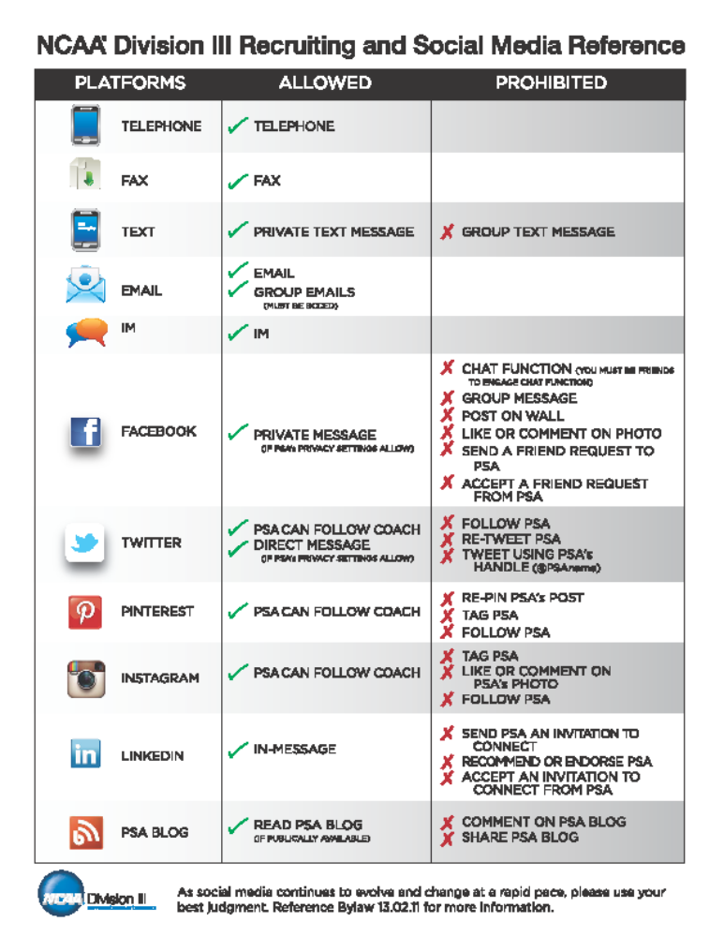

SPORTS CAMPS AND CLINICS

Institution’s Sports Camps and Clinics
An institution’s sports camp or instructional clinic shall be any camp or clinic that is owned or operated by a member institution or an employee of the member institution’s athletics department, either on or off its campus, (13.12.1.1)

Format of Camps or Clinics
An institution’s sports camp or clinic shall include instruction or practice programming. The sports camp or clinic may also include competition, but shall not be solely comprised of competition. Additionally, the camp or clinic shall be one that:
- Places special emphasis on a particular sport or sports and provides specialized instruction or practice and may include competition;
- Involves activities designed to improve overall skills and general knowledge in the sport; or
- Offers a diversified experience without emphasis on instruction, practice or competition in any particular sport. (13.12.1.1.1)

Attendance Restriction
A member institution’s sports camp or clinic shall be open to any and all entrants (limited only by number and age). (13.12.1.2)

Advertisements
Restrictions relating to advertisements of an institution’s sports camps and clinics in recruiting publications are set forth in Bylaw 13.4. Such restrictions do not apply to sports camp and clinic advertisements in non recruiting publications (e.g., a member institution’s game program). (See Bylaw 12.5.1.7) ( 13.12.1.3)

Prospective Student-Athletes/No Free or Reduced Admission Privileges
In operating a sports camp or clinic, an institution, members of its staff or a representative of its athletics interests shall not give free or reduced admission privileges to any individual who has started classes for the ninth grade. (13.12.1.4)

Payment of Expenses
A representative of an institution’s athletics interests may not pay a prospective student-athlete’s expenses to attend a member institution’s sports camp or clinic. (13.12.1.4.1)

Awards and Mementos
Prospective student-athletes may receive awards and mementos from a member institution’s sports camp or clinic. The costs of such awards are included in the admissions fees charged for participants in the camp or clinic. (13.12.1.4.2)

Recruiting Activities
Athletics department staff members shall not engage in recruiting activities during institutional sports camps or clinics. Non athletics institutional staff members may present and provide general institutional information to camp participants. (13.12.1.5)

Employment at Camp or Clinic
Prospective Student-Athletes- An institution may employ a prospective student-athlete at its institutional sports camp and/or clinic provided all compensation received by the prospective student-athlete is for work actually performed and at a rate commensurate with the going rate in that locality for similar services. (13.12.2.1)
Student-Athletes- A student-athlete who is employed in any sports camp or clinic must meet the following requirements:
- The student-athlete must perform duties that are of a general supervisory character in addition to any coaching or officiating assignments;

- Compensation provided to the student-athlete shall be commensurate with the going rate for camp or clinic counselors of like teaching ability and camp or clinic experience and may not be paid on the basis of the value that the student-athlete may have for the employer because of the athletics reputation or fame the student-athlete has achieved. It is not permissible to establish varying levels of compensation for a student-athlete employed in a sports camp or clinic based on the level of athletics skills of the student-athlete; and
- A student-athlete who only lectures or demonstrates at a camp/clinic may not receive compensation for his or her appearance at the camp/clinic. (13.12.2.2)

Self-Employment
A student-athlete with remaining eligibility is not permitted to conduct his or her own camp or clinic. (13.12.2.2.1.1)
Travel Expenses
A student-athlete may receive actual travel expenses (including lodging and meals in transit and prepaid plane tickets or cash advances) provided such expenses are paid for all employees of the camp/clinic. (13.12.2.2.1.2)

Cash Advances Based on Anticipated Earnings
In the case in which all employees do not receive travel expenses, a cash advance based on anticipated earnings may be provided to a student-athlete only if such advance does not exceed the estimated actual and necessary cost of travel or the student-athlete’s estimated employment earnings, whichever is less, and such a benefit is available to all camp employees. (13.12.2.2.1.3)

Employment in Own Institution’s Camp or Clinic
A member institution (or employees of its athletics department) may employ its student-athletes as counselors in camps or clinics, provided the student-athletes do not participate in organized practice activities other than during the institution’s playing season in the sport. (see Bylaw 17.1.1) (13.12.2.2.2)

High School, Preparatory School or Two-Year College Coaches
A member institution (or employees of its athletics department) may employ a high school, preparatory school or two-year college coach at its camp or clinic. (13.12.2.3)

Athletics Staff Members
A member institution’s athletics staff member may be involved in sports camps or clinics unless otherwise prohibited in this section. (13.12.2.4)

Camp/Clinic Providing Recruiting or Scouting Service
No athletics department staff member may be employed (either on a salaried or a volunteer basis) in any capacity by a camp or clinic established, sponsored or conducted by an individual or organization that provides recruiting or scouting services concerning prospective student-athletes. This provision does not prohibit an athletics department staff member from participating in an officiating camp in which participants officiate for, but are not otherwise involved in, a scouting services camp. (13.12.2.4.1)

Concession Arrangement
A prospective or enrolled student-athlete, at his or her own expense, may not operate a concession to sell items related to or associated with the institution’s camp. However, the institution may employ the prospective or enrolled student-athlete at a rate commensurate with the going rate in that locality for similar services. (13.12.2.5)

Privately Owned Camp
An institution’s athletics department personnel may serve in any capacity (e.g., guest lecturer, consultant) in a privately owned camp, clinic or coaching school at which prospective student athletes who have started the ninth grade are employed, provided the camp or clinic operates in accordance with the following conditions:
- The camp or clinic shall be open to the general public; and
- The camp or clinic shall not give free or reduced admission privileges to any individual who has started classes for the ninth grade.

Payment of Expenses
It is not permissible for a representative of an institution’s athletics interests to pay a prospective student-athlete’s expenses to attend a privately owned sports camp, clinic or coaching school. (13.12.4.1)

Advertisements
Restrictions related to the advertising of private camps or clinics involving student- athletes are set forth in Bylaw 12.5.1.7.

2014-15 DIVISION III COMPLIANCE FORMS
- Summary of Regulations
- Form 13-3c: Student-Athlete Statement
- Form 13-3f: Drug-Testing Consent Form - Championships Segment
- Form 13-10c: General Amateurism and Eligibility Form for International and Select Student-Athletes
- Permission to Contact: Self-Release Form
- HIPAA/Buckley Amendment Consent/Waiver Form (Please note: this form is optional.)
- Banned Drugs Educational

RELEVANT TOPICS AND OTHER NCAA RESOURCES
- NCAA Division III Philosophy Statement (Philosophy statement produced by the NCAA pertaining to Division III athletics)
- NCAA Division III Website (Up to the minute information on Division III athletics)
- NCAA Getting in the Game (Videos and resources for athletes, parents and administrators)
- Don't Bet On It (Video resource on sports wagering)

